Step By Step – Working on Community Site in SharePoint 2013-Office 365

Creating New Site Collection:

* Login to the SharePoint Central administration 2013 with the administrator user credentials
* In the Site Admin Center page, Click Site Collections link
* Click New 🡪Private Site Collection
* Provide the details for the new site collections

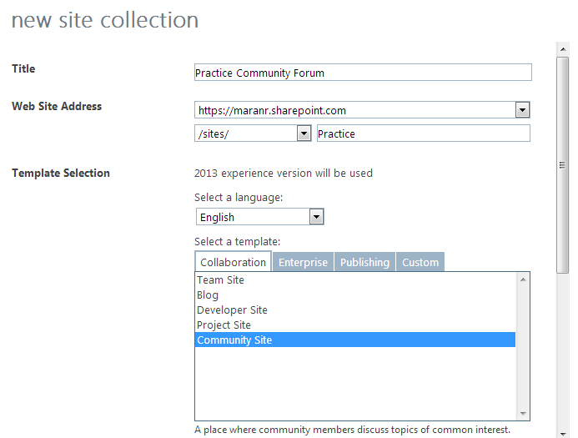

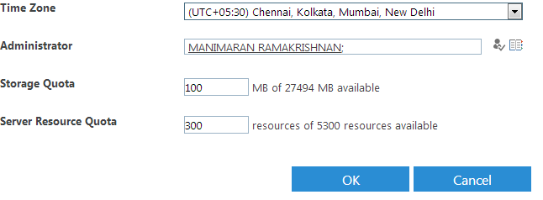

* Once clicking the OK button, the site collections will be created.

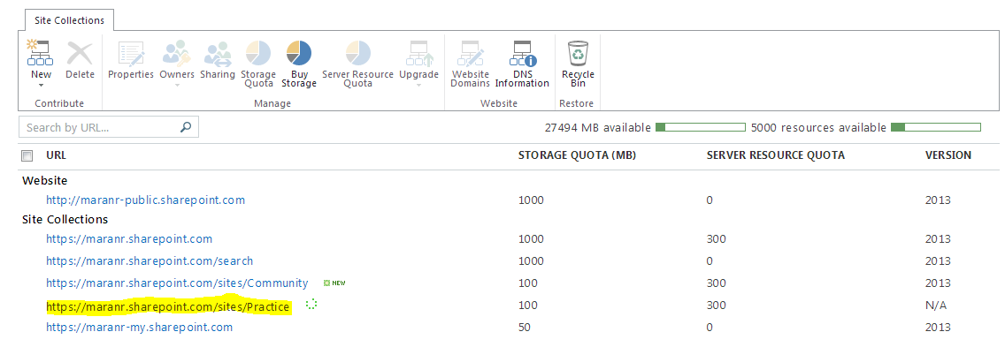

Contents of Community Site:

Following are the default list and libraries which will be created in the site collection.

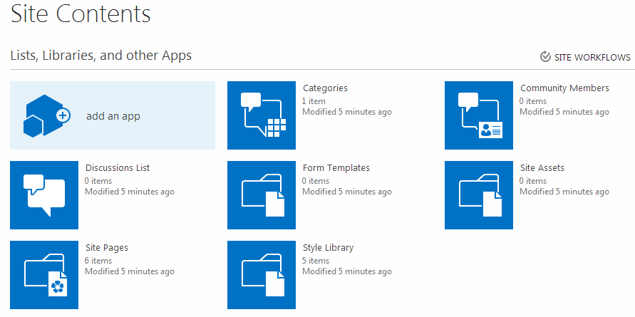

Of all, following is the main lists are

* Categories
* Community Members
* Discussions List

**Discussions List** 

Using this list we can do the forum-style question and answer, Conversations on the topics among the users.

**Categories** 

Using this list we can define some categories which we can use in Discussion list while creating the Discussion posts. By Default a category called “General” will be created.

**Community Members**  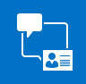

This list keep track a record of ongoing activity by members and reputation they accrue within this community.

Community Tools:

Other than the above list, this community site will has some extra tools for the admin user. Following are the tools available

* Manage Discussions
* Create Categories
* Create Badges
* Assign badges to Members
* Reputation settings
* Community settings

# Manage Discussions

On Clicking the Manage Discussions it will display all the discussion created by the users. With this the admin can mark some of the Discussion as “Featured”.

**Mark/Un-Mark a Discussion as Featured**

* In the Manage Discussion list, select the discussion thread that you want to mark as Featured Discussion.
* In the ribbon select “MODERATION” tab and select “Mark as Featured” or “Unmark as Featured”

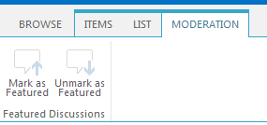

# Create Categories

Categories can be created using this link. You can create a new Category by clicking new item.

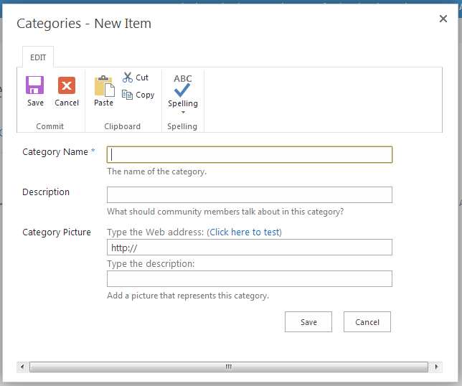

Here the Category Picture will be used if the user chooses the Title view of the category.

**Views available in Category List:**

* Category Titles – Show the Category in Titles view
* Admin View – Normal List View

**Category Titles View**

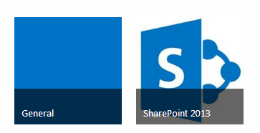

Admin View

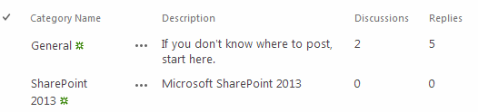

## Create Badges

Badge is something like a kind of Reorganization provided to the members based on their contributions. By default, below are the badges created.

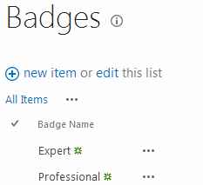

## Assign badges to members

Using this, the members will be assigned the badges created in the badges.

* To assign a badge, first select the user.
* In the ribbon select the **Moderation** tab and select **Give Badge**
* From the dropdown option the user can select and assign.

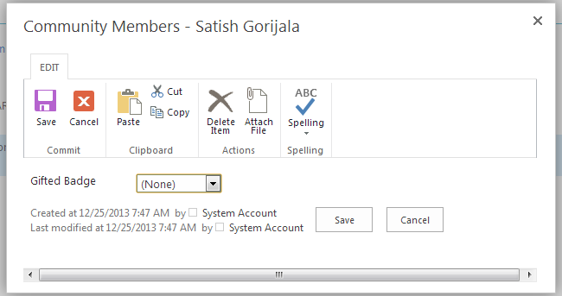

This badge will be available along with the user display icon.

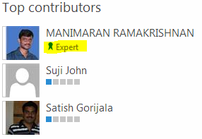

## Reputation Settings

This allows the admin to set the Reputations for the contributions on the discussion thread. Below are the settings

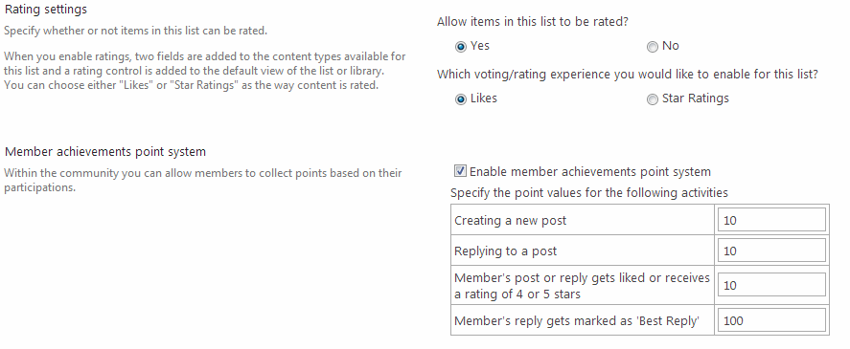

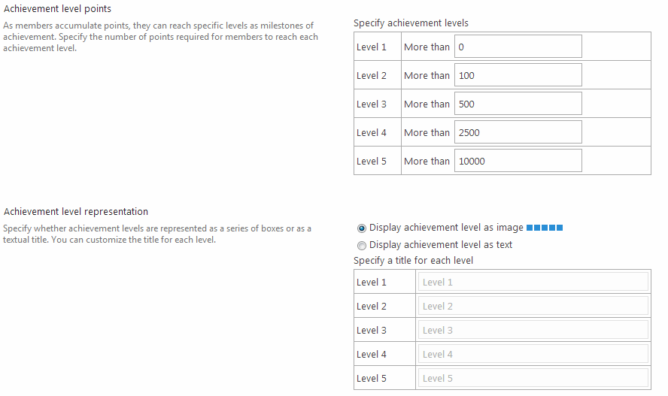

## Community Settings

Allow admin to set the approval for the users who are accessing this community site.

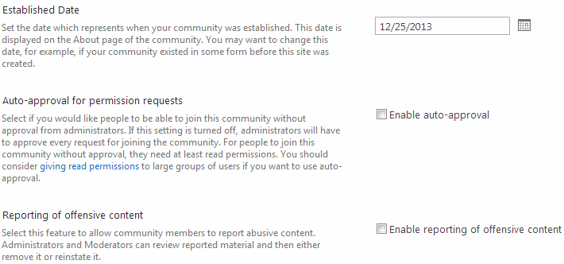

# Create New Discussion

On Clicking the New Discussion in the Home page, the following form will be displayed to create new thread. We can mark the discussion as Question by checking the option. Apart from that we can select the Category which we created in the Categories list.

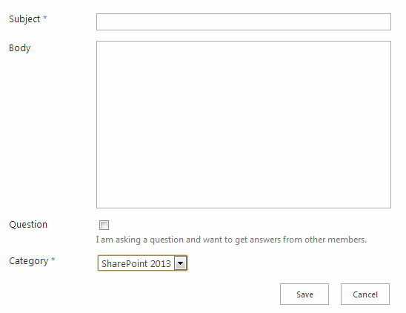

The Discussions will be listed as below.

